# UI – Performance Optimization

## Important Steps:

* Optimizing the Critical Rendering Path
* X
* X
* xx

## Critical Rendering Path

The Critical Rendering Path is the sequence of steps that the browser goes through to convert the HTML, CSS, and JavaScript into actual pixels on the screen. And,

if we can optimize that, then we can make our pages render fast

|  |  |
| --- | --- |
|  | * First we grab the HTML and we start building the document object model. * We then have to fetch the CSS and build the CSS object model. * We combine those two to create the Render Tree. * Then we have to figure out where everything goes on the page, which is the Layout step. * And then finally we can paint pixels on the actual screen.   1st we will talk about the construct a document object model, the CSS object model,  and then we'll talk about how JavaScript affects the actual rendering pipeline. |

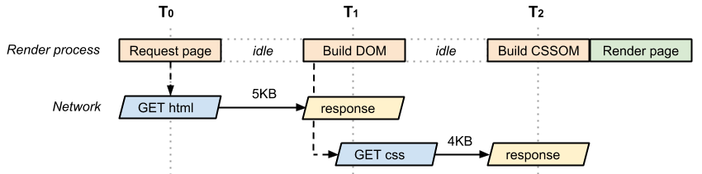

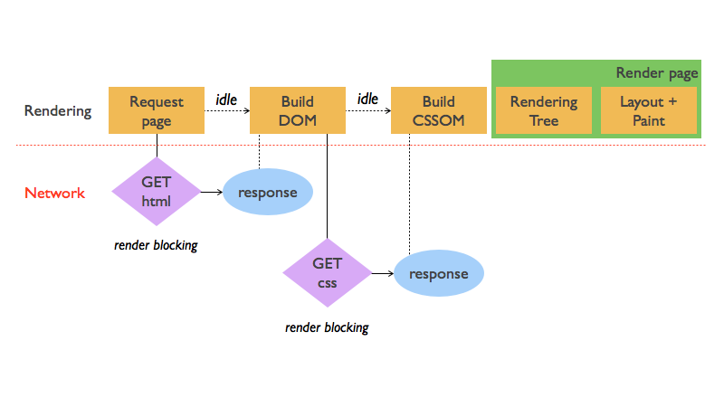

## 1st Understand, How “Browser” works ?

* Bytes → characters → tokens → nodes → object model.
* HTML markup is transformed into a Document Object Model (DOM)
* CSS markup is transformed into a CSS Object Model (CSSOM)

|  |
| --- |
| <!DOCTYPE html> <html>   <head>     <meta name="viewport" content="width=device-width,initial-scale=1">     <link href="style.css" rel="stylesheet">     <title>Critical Path</title>   </head>   <body>     <p>Hello <span>web performance</span> students!</p>     <div><img src="awesome-photo.jpg"></div>   </body> </html> |
| OM construction process |

### 1. DOM - Tree Construction:

1. **Byte to Character Conversion:**
   * The browser reads the raw bytes of HTML off the disk or network,
   * and translates them to individual characters based on specified encoding of the file (for example, UTF-8).
2. **Character to Token Conversion:**
   * The browser converts strings of characters into distinct tokens—as specified by the W3C HTML5 standard;
   * for example, "<html>", "<body>"—and other strings within angle brackets.
   * Each token has a special meaning and its own set of rules.
3. **Tokens to Nodes/Objects (Lexing):**
   * The emitted tokens are converted into "objects," which define their properties and rules.
4. **DOM Tree construction:**
   * Finally, because the HTML markup defines relationships between different tags
   * (some tags are contained within other tags) the created objects are linked in a tree data structure
   * that also captures the parent-child relationships defined in the original markup:
   * the HTML object is a parent of the body object, the body is a parent of the paragraph object, and so on.

Every time the browser processes HTML markup, it goes through all of the steps above

This entire process can take some time, especially if we have a large amount of HTML to process.

### 2. CSSOM - Tree Construction:

While the browser was constructing the DOM of our simple page, if it encounters a link tag in the head section of the document referencing an external CSS stylesheet: style.css. Anticipating that it needs this resource to render the page, it immediately dispatches a request for this resource, which comes back with the following content:

style.css

body { font-size: 16px }  
p { font-weight: bold }  
span { color: red }  
p span { display: none }  
img { float: right }

As with HTML, we need to convert the received CSS rules into something that the browser can understand and work with. Hence, we repeat the HTML process, but for CSS instead of HTML:



The CSS bytes are converted into characters, then tokens, then nodes, and finally they are linked into a tree structure known as the

**"CSS Object Model" (CSSOM) Tree:**

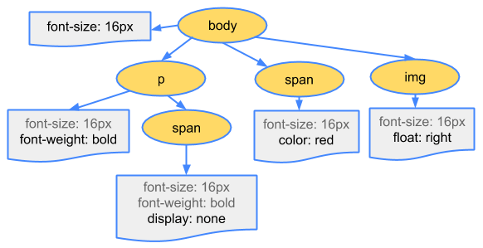

**Why does the CSSOM have a tree structure?**

* When computing the final set of styles for any object on the page, the browser starts with the most general rule applicable to that node (for example, if it is a child of a body element, then all body styles apply) and then recursively refines the computed styles by applying more specific rules; that is, the rules "cascade down."

To make it more concrete, consider the CSSOM tree above. Any text contained within the span tag that is placed within the body element, has a font size of 16 pixels and has red text—the font-size directive cascades down from the body to the span. However, if a span tag is child of a paragraph (p) tag, then its contents are not displayed.

Also, note that the above tree is not the complete CSSOM tree and only shows the styles we decided to override in our stylesheet. Every browser provides a default set of styles also known as "user agent styles"

### 3. Render-tree Construction, Layout, and Paint

First, the browser combines the DOM and CSSOM into a "Render Tree," which captures all the visible DOM content on the page and all the CSSOM style information for each node.

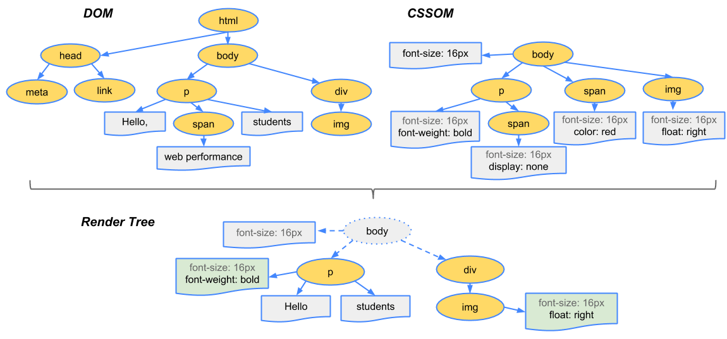

To construct the render tree, the browser roughly does the following:

1. Starting at the root of the DOM tree, traverse each visible node.
   * + - Some nodes are not visible (for example, script tags, meta tags, and so on), and are omitted since they are not reflected in the rendered output.
       - Some nodes are hidden via CSS and are also omitted from the render tree; for example, the span node---in the example above---is missing from the render tree because we have an explicit rule that sets the "display: none" property on it.
2. For each visible node, find the appropriate matching CSSOM rules and apply them.
3. Emit visible nodes with content and their computed styles.

With the render tree in place, we can proceed to the **"Layout"** stage.

* Up to this point we've calculated which nodes should be visible and their computed styles,
* but we have not calculated their exact position and size within the viewport of the device
  + ---that's the **"layout"** stage, also known as "reflow."

|  |
| --- |
| <!DOCTYPE html> <html>   <head>     <meta name="viewport" content="width=device-width,initial-scale=1">     <title>Critial Path: Hello world!</title>   </head>   <body>     <div style="width: 50%">       <div style="width: 50%">Hello world!</div>     </div>   </body> </html> |
| The body of the above page contains two nested div's: the first (parent) div sets the display size of the node to 50% of the viewport width, and the second div---contained by the parent---sets its width to be 50% of its parent; that is, 25% of the viewport width.  alculating layout information  The output of the layout process is a "box model," which precisely captures the exact position and size of each element within the viewport: all of the relative measurements are converted to absolute pixels on the screen.  Finally, now that we know which nodes are visible, and their computed styles and geometry,  we can pass this information to the final stage (Painting),  which converts each node in the render tree to actual pixels on the screen.  easuring layout in DevTools   * The "Layout" event captures the Render-Tree construction, position, and size calculation in the Timeline. * When layout is complete, the browser issues "Paint Setup" and "Paint" events,   + which convert the render tree to pixels on the screen. |
| The time required to perform render tree construction, layout and paint varies based on   * the size of the document, * the applied styles, * and the device it is running on: * the larger the document, * the more work the browser has; the more complicated the styles, * the more time taken for painting also * (for example, a solid color is "cheap" to paint, while a drop shadow is "expensive" to compute and render).   endered Hello World page  The page is finally visible in the viewport: Rendered Hello World page |

**Quick Recap (Broswer Actions):**

1. Process HTML markup and build the DOM tree.
2. Process CSS markup and build the CSSOM tree.
3. Combine the DOM and CSSOM into a Render tree.
4. Run Layout on the render tree to compute geometry of each node.
5. Paint the individual nodes to the screen.

* Our demo page may look simple, but it requires quite a bit of work.
* If either the DOM or CSSOM were modified,
  + you would have to repeat the process in order to figure out which pixels would need to be re-rendered on the screen.

Optimizing the Critical Rendering Path **(CRP)**

* is the process of minimizing the total amount of time spent performing steps 1 through 5 in the above sequence.
* Doing so, renders content to the screen as quickly as possible
  + and also reduces the amount of time between screen updates after the initial render;
  + that is, achieve higher refresh rates for interactive content.

## Render Blocking CSS

* By default, CSS is treated as a **render-blocking** resource,
* which means that the browser won't render any processed content until the CSSOM is constructed.
* Make sure to keep your CSS lean, deliver it as quickly as possible,
  + and use media types and queries to unblock rendering.

***“CSS is a render blocking resource.***

***Get it to the client as soon and as quickly as possible --to optimize the time to first render.”***

* keep unnecessary code outside
  + - style.css           // body { font-size: 5px }
    - style-print.css  // @media print { body { font-size: 5px } }

*<!-- render-blocking CSS -->*

<link href="style.css" rel="stylesheet">

<link href="style.css" rel="stylesheet" media="all">

*<!-- NOT render-blocking CSS (since media is not print mode or large screen or portrait)-->*

<link href="print.css" rel="stylesheet" media="print">

<link href="other.css" rel="stylesheet" media="(min-width: 40em)">

<link href="portrait.css" rel="stylesheet" media="orientation:portrait">

In either case, the browser still downloads the CSS asset, with a lower priority for non-blocking resources

## Let’s see what JavaScript can do

* JavaScript is a dynamic language that runs in a browser
  + allows us to modify just about every aspect of the page: content, styling, and its response to user interaction.
    - we can modify content by adding and removing elements from the DOM tree;
    - we can modify the CSSOM properties of each element;
    - we can handle user input; and much more.
* However, JavaScript can also block DOM construction and delay when the page is rendered.
* To deliver optimal performance,
  + make your JavaScript async
  + and eliminate any unnecessary JavaScript from the critical rendering path
* JavaScript can query and modify the DOM and the CSSOM.
* JavaScript execution blocks on the CSSOM.
* JavaScript blocks DOM construction unless explicitly declared as async.

|  |
| --- |
| <!DOCTYPE html> <html>   <head>     <meta name="viewport" content="width=device-width,initial-scale=1">     <link href="style.css" rel="stylesheet">     <title>Critical Path: Script</title>   </head>   <body>     <p>Hello <span>web performance</span> students!</p>     <div><img src="awesome-photo.jpg"></div>     <script>       var span = document.getElementsByTagName('span')[0];       span.textContent = 'interactive'; // change DOM text content       span.style.display = 'inline';  // change CSSOM property         // create a new element, style it, and append it to the DOM       var loadTime = document.createElement('div');       loadTime.textContent = 'You loaded this page on: ' + new Date();       loadTime.style.color = 'blue';       document.body.appendChild(loadTime);     </script>   </body> </html>  style.css  body { font-size: 16px } p { font-weight: bold } span { color: red } p span { display: none } img { float: right } |
| * JavaScript allows us to reach into the DOM and pull out the reference to the hidden span node;   + the node may not be visible in the render tree, but it's still there in the DOM. T   + hen, when we have the reference, we can change its text (via .textContent),   + and even override its calculated display style property from "none" to "inline."   + Now our page displays "**Hello interactive students!**". * JavaScript also allows us to create, style, append, and remove new elements in the DOM. * Technically, our entire page could be just one big JavaScript file that creates and styles the elements one by one. * Although that would work, in practice using HTML and CSS is much easier. * In the second part of our JavaScript function we create a new div element, set its text content, style it, and append it to the body.   age preview |

* First, notice that in the above example our inline script is near the bottom of the page. Why? Well, you should try it yourself, but if we move the script above the span element, you'll notice that the script fails and complains that it cannot find a reference to any span elements in the document; that is, getElementsByTagName(‘span') returns null.
* This demonstrates an important property:
  + our script is executed at the exact point where it is inserted in the document.
* When the HTML parser encounters a script tag,
  + it pauses its process of constructing the DOM
  + and yields control to the JavaScript engine;
  + after the JavaScript engine finishes running,
  + the browser then picks up where it left off and resumes DOM construction.

**“executing our inline script blocks DOM construction, which also delays the initial render”**

* Another subtle property of introducing scripts into our page is that
  + they can read and modify not just the DOM,
  + but also the CSSOM properties.
* In fact, that's exactly what we're doing in our example
  + when we change the display property of the span element from none to inline.
  + The end result? We now have a race condition.
* What if the browser **hasn't** finished downloading and **building** the **CSSOM** when we want to run our script?
* The answer is simple and **not very good for performance**:
  + the browser delays script execution and DOM construction
  + until it has finished downloading and constructing the CSSOM

In short, JavaScript introduces a lot of new dependencies between the DOM, the CSSOM, and JavaScript execution.

This can cause the browser significant delays in processing and rendering the page on the screen:

* The location of the script in the document is significant.
* When the browser encounters a script tag, DOM construction pauses until the script finishes executing.
* JavaScript can query and modify the DOM and the CSSOM.
* JavaScript execution pauses until the CSSOM is ready.

To a large degree, "optimizing the critical rendering path" refers to

* **understanding** and **optimizing** the **dependency** graph **between** HTML, CSS, and JavaScript.

## Parser Blocking – JavaScript vs Asynchronous JavaScript

By default, JavaScript execution is "parser blocking":

* when the browser encounters a script in the document
* it must pause DOM construction, hand over control to the JavaScript runtime,
* and let the script execute before proceeding with DOM construction.
* We saw this in action with an inline script in our earlier example.
* In fact, inline scripts are always parser blocking unless you write additional code to defer their execution.

What about scripts included via a script tag? Let's take our previous example and extract the code into a separate file:

|  |
| --- |
| <!DOCTYPE html> <html>   <head>     <meta name="viewport" content="width=device-width,initial-scale=1">     <link href="style.css" rel="stylesheet">     <title>Critical Path: Script External</title>   </head>   <body>     <p>Hello <span>web performance</span> students!</p>     <div><img src="awesome-photo.jpg"></div>     <script src="app.js"></script>   </body> </html>  app.js  var span = document.getElementsByTagName('span')[0]; span.textContent = 'interactive'; // change DOM text content span.style.display = 'inline';  // change CSSOM property   // create a new element, style it, and append it to the DOM var loadTime = document.createElement('div'); loadTime.textContent = 'You loaded this page on: ' + new Date(); loadTime.style.color = 'blue'; document.body.appendChild(loadTime); |

* Whether we use a <script> tag or an inline JavaScript snippet,
  + you'd expect both to behave the same way.
  + In both cases, the browser pauses and executes the script before it can process the remainder of the document.
* However, in the case of an external JavaScript file
  + the browser must pause to wait for the script to be fetched from disk, cache, or a remote server,
  + which can add tens to thousands of milliseconds of delay to the critical rendering path.

Adding the ‘async’ keyword to the script tag tells the browser not to block DOM construction while it waits for the script to become available, which can significantly improve performance.

<!DOCTYPE html>  
<html>  
  <head>  
    <meta name="viewport" content="width=device-width,initial-scale=1">  
    <link href="style.css" rel="stylesheet">  
    <title>Critical Path: Script Async</title>  
  </head>  
  <body>  
    <p>Hello <span>web performance</span> students!</p>  
    <div><img src="awesome-photo.jpg"></div>  
    <script src="app.js" async></script>  
  </body>  
</html>

## Measuring the Critical Rendering Path

* The foundation of every solid performance strategy is good measurement and instrumentation.
* You can't optimize what you can't measure

Different approaches for measuring CRP performance.

* The Lighthouse approach runs a series of automated tests against a page, and then generates a report on the page's CRP performance. This approach provides a quick and easy high-level overview of CRP performance of a particular page loaded in your browser, allowing you to rapidly test, iterate, and improve its performance.
* 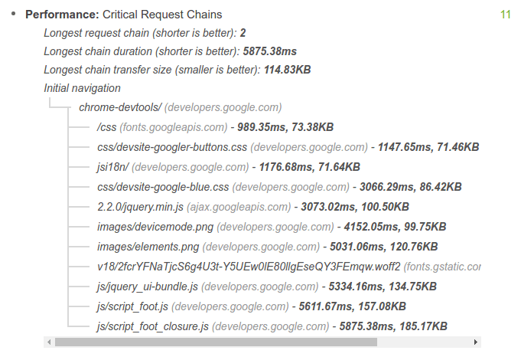
* The Navigation Timing API approach captures Real User Monitoring (RUM) metrics. As the name implies, these metrics are captured from real user interactions with your site and provide an accurate view into real-world CRP performance, as experienced by your users across a variety of devices and network conditions.

The combination of the Navigation Timing API and other browser events emitted as the page loads allows you to capture and record the real-world CRP performance of any page.

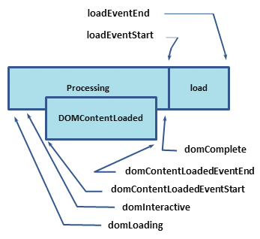

<!DOCTYPE html>  
<html>  
  <head>  
    <title>Critical Path: Measure</title>  
    <meta name="viewport" content="width=device-width,initial-scale=1">  
    <link href="style.css" rel="stylesheet">  
    <script>  
      function measureCRP() {  
        var t = window.performance.timing,  
          interactive = t.domInteractive - t.domLoading,  
          dcl = t.domContentLoadedEventStart - t.domLoading,  
          complete = t.domComplete - t.domLoading;  
        var stats = document.createElement('p');  
        stats.textContent = 'interactive: ' + interactive + 'ms, ' +  
            'dcl: ' + dcl + 'ms, complete: ' + complete + 'ms';  
        document.body.appendChild(stats);  
      }  
    </script>  
  </head>  
  <body onload="measureCRP()">  
    <p>Hello <span>web performance</span> students!</p>  
    <div><img src="awesome-photo.jpg"></div>  
  </body>  
</html>



***“Google Analytics does this automatically”***

## Analyzing Critical Rendering Path Performance

Identifying and resolving critical rendering path performance bottlenecks requires good knowledge of the common pitfalls.

Optimizing the critical rendering path allows the browser to paint the page as quickly as possible:

* faster pages translate into higher engagement, more pages viewed, and improved conversion.
* To minimize the amount of time a visitor spends viewing a blank screen,
* we need to optimize which resources are loaded and in which order.

To help illustrate this process, let's start with the simplest possible case

* and incrementally build up our page to include additional resources, styles, and application logic.
* In the process, we'll optimize each case; we'll also see where things can go wrong.

So far we've focused exclusively on what happens in the browser after the resource (CSS, JS, or HTML file) is available to process.

* We've ignored the time it takes to fetch the resource either from cache or from the network.

We'll assume the following:

* A network roundtrip (propagation latency) to the server costs 100ms.
* Server response time is 100ms for the HTML document and 10ms for all other files.

### Analyzing: CRP (simple HTML –with no CSS & JS)

We'll start with basic HTML markup and a single image; no CSS or JavaScript.

<!DOCTYPE html>  
<html>  
  <head>  
    <meta name="viewport" content="width=device-width,initial-scale=1">  
    <title>Critical Path: No Style</title>  
  </head>  
  <body>  
    <p>Hello <span>web performance</span> students!</p>  
    <div><img src="awesome-photo.jpg"></div>  
  </body>  
</html>

Let's open up our Network timeline in Chrome DevTools and inspect the resulting resource waterfall:

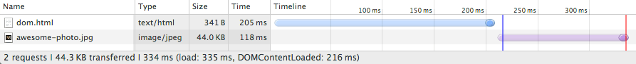

As expected, the HTML file took approximately 200ms to download.

* Note that the transparent portion of the blue line represents the length of time that the browser waits on the network without receiving any response bytes
* whereas the solid portion shows the time to finish the download after the first response bytes have been received.
* The HTML download is tiny (<4K), so all we need is a single roundtrip to fetch the full file.
* As a result, the HTML document takes approximately 200ms to fetch, with half the time spent waiting on the network and the other half waiting on the server response.

When the HTML content becomes available,

* the browser parses the bytes, converts them into tokens, and builds the DOM tree.
* Notice that DevTools conveniently reports
  + the time for the DOMContentLoaded event at the bottom (216ms),
  + which also corresponds to the blue vertical line.
* The gap between the end of the HTML download and the blue vertical line (DOMContentLoaded)
  + is the **time** it takes the browser to **build the DOM tree**—in this case, just a few milliseconds.

Notice that our "awesome photo" **did not block the***domContentLoaded***event**.

* Turns out, we can construct the render tree and even paint the page without waiting for each asset on the page:
* “**not all resources are critical to deliver the fast first paint**.

In fact, when we talk about the critical rendering path we are typically talking about the HTML markup, CSS, and JavaScript.

* Images do not block the initial render of the page—although we should also try to get the images painted as soon as possible.

That said, the load event (also known as onload), is blocked on the image:

* DevTools reports the onload event at 335ms.
* Recall that the onload event marks the point at which **all resources** that the page requires have been downloaded and processed; at this point,
* the loading spinner can stop spinning in the browser (the red vertical line in the waterfall).

### Analyzing: CRP (with HTML, CSS & JS)

### Let's add CSS and JS into the same HTML.

<!DOCTYPE html>  
<html>  
  <head>  
    <title>Critical Path: Measure Script</title>  
    <meta name="viewport" content="width=device-width,initial-scale=1">  
    <link href="style.css" rel="stylesheet">  
  </head>  
  <body onload="measureCRP()">  
    <p>Hello <span>web performance</span> students!</p>  
    <div><img src="awesome-photo.jpg"></div>  
    <script src="timing.js"></script>  
  </body>  
</html>

*Before adding JavaScript and CSS:*



*With JavaScript and CSS:*

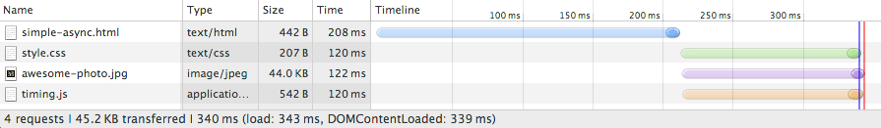

Adding external CSS and JavaScript files adds two extra requests to our waterfall,

* all of which the browser dispatches at about the same time.
* However, **note that there is now a much smaller timing difference between the domContentLoaded and onload events.**

**What happened?**

* Unlike our plain HTML example,
  + we also need to fetch and parse the CSS file to construct the CSSOM,
  + and we need both the DOM and CSSOM to build the render tree.
* Because the page also contains a parser blocking JavaScript file,
* the *domContentLoadedevent* is blocked until the CSS file is downloaded and parsed:
* because the JavaScript might query the CSSOM,
* we must block the CSS file until it downloads before we can execute JavaScript.

**What if we replace our external script with an inline script?**

* Even if the script is inlined directly into the page, the browser can't execute it until the CSSOM is constructed.
* In short, inlined JavaScript is also parser blocking.

That said, despite blocking on CSS, does inlining the script make the page render faster? Let's try it and see what happens.

*External JavaScript:*



*Inlined JavaScript:*

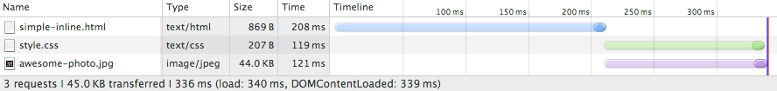

We are making one less request, but both our onload and domContentLoaded times are effectively the same.

Why? Well, we know that it doesn't matter if the JavaScript is inlined or external,

* because as soon as the browser hits the script tag it blocks and waits until the CSSOM is constructed.
* Further, in our first example, the browser downloads both CSS and JavaScript in parallel and they finish downloading at about the same time.
* In this instance, inlining the JavaScript code doesn't help us much.
* But there are several strategies that can make our page render faster.

First, recall that **all inline scripts are parser blocking**, but for external scripts we can add the "async" keyword to unblock the parser.

*Parser-blocking (external) JavaScript:*



*Async (external) JavaScript:*

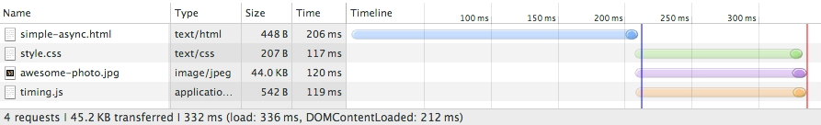

Much better! The domContentLoaded event fires shortly after the HTML is parsed; the browser knows not to block on JavaScript and since there are no other parser blocking scripts the CSSOM construction can also proceed in parallel.

Alternatively, we could have inlined both the CSS and JavaScript:

<!DOCTYPE html>  
<html>  
  <head>  
    <title>Critical Path: Measure Inlined</title>  
    <meta name="viewport" content="width=device-width,initial-scale=1">  
    <style>  
      p { font-weight: bold }  
      span { color: red }  
      p span { display: none }  
      img { float: right }  
    </style>  
  </head>  
  <body>  
    <p>Hello <span>web performance</span> students!</p>  
    <div><img src="awesome-photo.jpg"></div>  
    <script>  
      var span = document.getElementsByTagName('span')[0];  
      span.textContent = 'interactive'; // change DOM text content  
      span.style.display = 'inline';  // change CSSOM property  
      // create a new element, style it, and append it to the DOM  
      var loadTime = document.createElement('div');  
      loadTime.textContent = 'You loaded this page on: ' + new Date();  
      loadTime.style.color = 'blue';  
      document.body.appendChild(loadTime);  
    </script>  
  </body>  
</html>



Notice that the *domContentLoaded*time is effectively the same as in the previous example;

* instead of marking our JavaScript as async,
* we've inlined both the CSS and JS into the page itself.
* This makes our HTML page much larger,
* but the upside is that the browser doesn't have to wait to fetch any external resources;
* everything is right there in the page.

As you can see, even with a very simple page,

* optimizing the critical rendering path is a non-trivial exercise:
* we need to understand the dependency graph between different resources,
* we need to identify which resources are "critical,"
* and we must choose among different strategies for how to include those resources on the page.
* There is no one solution to this problem; each page is different.
* You need to follow a similar process on your own to figure out the optimal strategy.

That said, let's see if we can step back and identify some general performance patterns.

## Performance patterns

The simplest possible page consists of just the HTML markup; no CSS, no JavaScript, or other types of resources.

<!DOCTYPE html>  
<html>  
  <head>  
    <meta name="viewport" content="width=device-width,initial-scale=1">  
    <title>Critical Path: No Style</title>  
  </head>  
  <body>  
    <p>Hello <span>web performance</span> students!</p>  
    <div><img src="awesome-photo.jpg"></div>  
  </body>  
</html>

To render this page the

* browser has to initiate the request,
* wait for the HTML document to arrive,
* parse it, build the DOM,
* and then finally render it on the screen:

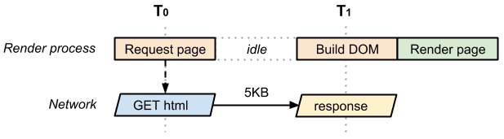

**The time between T0 and T1 captures the network and server processing times.**

* In the best case (if the HTML file is small), just one network roundtrip fetches the entire document.
* Due to how the TCP transports protocols work, larger files may require more roundtrips.
* **As a result, in the best case the above page has a one roundtrip (minimum) critical rendering path.**

Now, let's consider the same page but with an external CSS file:

<!DOCTYPE html>  
<html>  
  <head>  
    <meta name="viewport" content="width=device-width,initial-scale=1">  
    <link href="style.css" rel="stylesheet">  
  </head>  
  <body>  
    <p>Hello <span>web performance</span> students!</p>  
    <div><img src="awesome-photo.jpg"></div>  
  </body>  
</html>



Once again, we incur a network roundtrip to fetch the HTML document,

* and then the retrieved markup tells us that we also need the CSS file;
* this means that the browser has to go back to the server and get the CSS before it can render the page on the screen.
* **As a result, this page incurs a minimum of two roundtrips before it can be displayed.**
  + Once again, the CSS file may take multiple roundtrips, hence the emphasis on "minimum".

Let's define the vocabulary we use to describe the critical rendering path:

* **Critical Resource:** Resource that could block initial rendering of the page.
* **Critical Path Length:** Number of roundtrips, or the total time required to fetch all of the critical resources.
* **Critical Bytes:** Total number of bytes required to get to first render of the page, which is the sum of the transfer filesizes of all critical resources. Our first example, with a single HTML page, contained a single critical resource (the HTML document); the critical path length was also equal to one network roundtrip (assuming file was small), and the total critical bytes was just the transfer size of the HTML document itself.



* **2** critical resources
* **2** or more roundtrips for the minimum critical path length
* **9** KB of critical bytes

We need both the HTML and CSS to construct the render tree.

* As a result, both **HTML** and **CSS** are critical resources:
* the CSS is fetched only after the browser gets the HTML document,
* hence the critical path length is at minimum two roundtrips.
* Both resources add up to a total of 9KB of critical bytes.

Now let's add an extra JavaScript file into the mix.

<!DOCTYPE html>  
<html>  
  <head>  
    <meta name="viewport" content="width=device-width,initial-scale=1">  
    <link href="style.css" rel="stylesheet">  
  </head>  
  <body>  
    <p>Hello <span>web performance</span> students!</p>  
    <div><img src="awesome-photo.jpg"></div>  
    <script src="app.js"></script>  
  </body>  
</html>

We added *app.js*, which is both an external JavaScript asset on the page and a parser blocking (that is, critical) resource. Worse, in order to execute the JavaScript file we have to block and wait for CSSOM; recall that JavaScript can query the CSSOM and hence the browser pauses until style.css is downloaded and CSSOM is constructed.

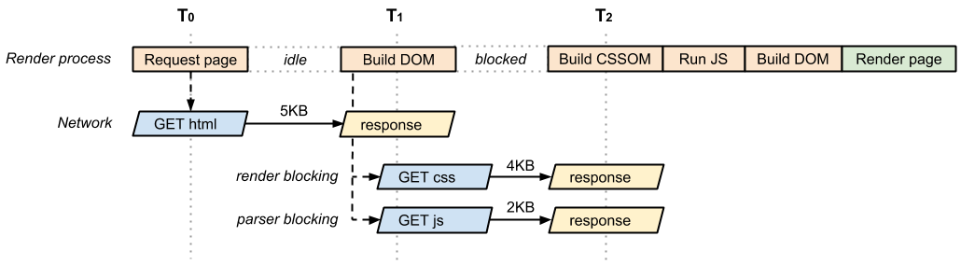

That said, in practice if we look at this page's "network waterfall,"

* you'll see that both the CSS and JavaScript requests are initiated at about the same time;
* the browser gets the HTML,
  + discovers both resources, and initiates both requests.
* As a result, the above page has the following critical path characteristics:
* **3** critical resources
* **2** or more roundtrips for the minimum critical path length
* **11** KB of critical bytes

We now have three critical resources that add up to 11KB of critical bytes,

* but our critical path length is still two roundtrips
* because we can transfer the CSS and JavaScript in parallel.

***“Figuring out the characteristics of your critical rendering path means being able to identify the critical resources and also understanding how the browser will schedule their fetches”***

Let's continue with our example.

After chatting with our site developers, we realize that the JavaScript we included on our page doesn't need to be blocking;

* we have some analytics and other code in there that doesn't need to block the rendering of our page.
* With that knowledge, we can add the "async" attribute to the script tag to unblock the parser:

<!DOCTYPE html>  
<html>  
  <head>  
    <meta name="viewport" content="width=device-width,initial-scale=1">  
    <link href="style.css" rel="stylesheet">  
  </head>  
  <body>  
    <p>Hello <span>web performance</span> students!</p>  
    <div><img src="awesome-photo.jpg"></div>  
    <script src="app.js" async></script>  
  </body>  
</html>

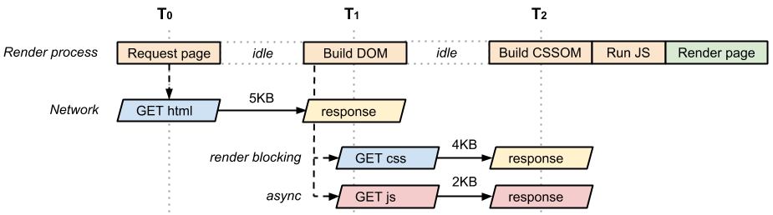

An asynchronous script has several advantages:

* The script is no longer parser blocking and is not part of the critical rendering path.
* Because there are no other critical scripts, the CSS doesn't need to block the domContentLoaded event.
* The sooner the *domContentLoaded*event fires, the sooner other application logic can begin executing.

As a result, our optimized page is now

* back to **2 critical resources** (HTML and CSS),
* with a minimum **critical path length** of **two roundtrips**,
* and a total of **9KB** of critical bytes

Finally, if the CSS stylesheet were only needed for print, how would that look?

<!DOCTYPE html>  
<html>  
  <head>  
    <meta name="viewport" content="width=device-width,initial-scale=1">  
    <link href="style.css" rel="stylesheet" media="print">  
  </head>  
  <body>  
    <p>Hello <span>web performance</span> students!</p>  
    <div><img src="awesome-photo.jpg"></div>  
    <script src="app.js" async></script>  
  </body>  
</html>

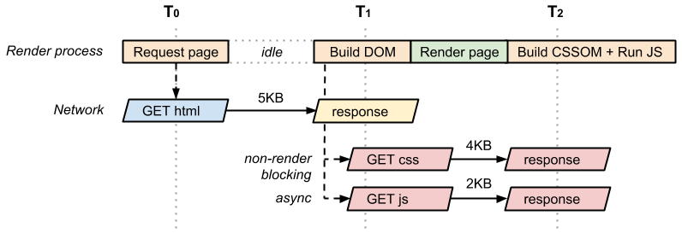

Because the style.css resource is only used for print, the browser doesn't need to block on it to render the page. Hence, as soon as DOM construction is complete, the browser has enough information to render the page.

As a result, this page has

* only a **1 critical resource** (the HTML document),
* and the minimum **critical rendering path length** is **1 roundtrip**.

### Optimizing the Critical Rendering Path

To deliver the fastest possible time to first render, we need to minimize three variables:

* The number of critical resources.
* The critical path length.
* The number of critical bytes.

A **critical resource** is a resource that could block initial rendering of the page.

* The fewer of these resources, the less work for the browser, the CPU, and other resources.

Similarly, the **critical path length** is a function of

* the dependency graph between the critical resources and their bytesize:
* some resource downloads can only be initiated after a previous resource has been processed,
* and the larger the resource the more roundtrips it takes to download.

Finally, the fewer **critical bytes** the browser has to download, the faster it can process content and render it visible on the screen.

To reduce the number of bytes, we can reduce the number of resources (eliminate them or make them non-critical) and ensure that we minimize the transfer size by compressing and optimizing each resource.

|  |
| --- |
| **The general sequence of steps to optimize the critical rendering path is:**   1. Analyze and characterize your critical path: number of resources, bytes, length. 2. Minimize number of **critical resources**: eliminate them, defer their download,    * mark JavaScript as async    * mark CSS as media="print" / media="print" / media="orientation:portrait" / media="(min-width: 40em)"    * and so on…. 3. Optimize the number of **critical bytes** to reduce the download time (number of roundtrips).    * minify: css/js    * remove: white space, comments    * compress: text (gzip, zopfli, brotli)    * no unnecessary resources: (no unecessary css/javascript –required for that page) (lazy load them) 4. Optimize the order in which the remaining critical resources are loaded:    * download all critical assets as early as possible to shorten the critical path length. |

**PageSpeed Rules and Recommendations**

Eliminate render-blocking JavaScript and CSS

* To deliver the fastest time to first render, minimize and (where possible) eliminate the number of critical resources on the page, minimize the number of downloaded critical bytes, and optimize the critical path length.

Optimize JavaScript use

* JavaScript resources are parser blocking by default unless marked as async or added via a special JavaScript snippet.
* Parser blocking JavaScript forces the browser to wait for the CSSOM and pauses construction of the DOM,
* which in turn can significantly delay the time to first render.

Prefer asynchronous JavaScript resources

* Asynchronous resources unblock the document parser and allow the browser to avoid blocking on CSSOM prior to executing the script. Often, if the script can use the async attribute, it also means it is not essential for the first render. Consider loading scripts asynchronously after the initial render.

Defer parsing JavaScript

* To minimize the amount of work the browser has to perform to render the page,
* defer any non-essential scripts that are **not critical** to constructing the visible content for the initial render.

Avoid long running JavaScript

* Long running JavaScript **blocks** the **browser** from constructing the DOM, CSSOM, and rendering the page,
* so defer until later any initialization logic and functionality that is non-essential for the first render. If a long initialization sequence needs to run, consider splitting it into several stages to allow the browser to process other events in between.

Optimize CSS Use

* CSS is required to construct the render tree and JavaScript often blocks on CSS during initial construction of the page.
* Ensure that any non-essential CSS is marked as non-critical (for example, print and other media queries), and that the amount of critical CSS and the time to deliver it is as small as possible.

Put CSS in the document head

* Specify all CSS resources as early as possible within the HTML document so that the browser can discover the <link> tags and dispatch the request for the CSS as soon as possible.

Avoid CSS imports

* The CSS import (@import) directive enables one stylesheet to import rules from another stylesheet file. However, avoid these directives because they introduce additional roundtrips into the critical path: the imported CSS resources are discovered only after the CSS stylesheet with the @import rule itself is received and parsed.

Inline render-blocking CSS

* For best performance, you may want to consider inlining the critical CSS directly into the HTML document.
* This eliminates additional roundtrips in the critical path and if done correctly can deliver a "one roundtrip" critical path length where only the HTML is a blocking resource.

Avoid synchronous server calls

* Use the navigator.sendBeacon() method to limit data sent by XMLHttpRequests in unloadhandlers. Because many browsers require such requests to be synchronous, they can slow page transitions, sometimes noticeably. The following code shows how to use navigator.sendBeacon() to send data to the server in the pagehide handler instead of in the unload handler.

<script>  
  function() {  
    window.addEventListener('pagehide', logData, false);  
    function logData() {  
      navigator.sendBeacon(  
        'https://putsreq.herokuapp.com/Dt7t2QzUkG18aDTMMcop',  
        'Sent by a beacon!');  
    }  
  }();  
</script>

The new fetch() method provides an easy way to asynchronously request data. Because it is not available everywhere yet, you should use feature detection to test for its presence before use. This method processes responses with Promises rather than multiple event handlers. Unlike the response to an XMLHttpRequest, a fetch response is a stream object starting in Chrome 43. This means that a call to json() also returns a Promise.

<script>  
fetch('./api/some.json')    
  .then(    
    function(response) {    
      if (response.status !== 200) {    
        console.log('Looks like there was a problem. Status Code: ' +  response.status);    
        return;    
      }  
      // Examine the text in the response    
      response.json().then(function(data) {    
        console.log(data);    
      });    
    }    
  )    
  .catch(function(err) {    
    console.log('Fetch Error :-S', err);    
  });  
</script>

The fetch() method can also handle POST requests.

<script>  
fetch(url, {  
  method: 'post',  
  headers: {    
    "Content-type": "application/x-www-form-urlencoded; charset=UTF-8"    
  },    
  body: 'foo=bar&lorem=ipsum'    
}).then(function() { // Additional code });  
</script>

* the browser blocks page rendering, until it receives and processes all of the CSS. CSS is render blocking
* why wait on styles –you don’t need

**JavaScript Async vs Inline vs Blocking**

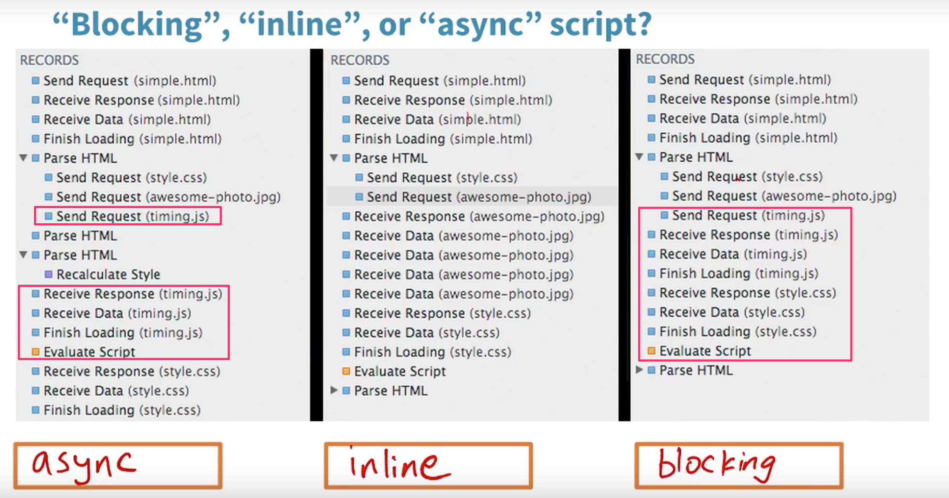

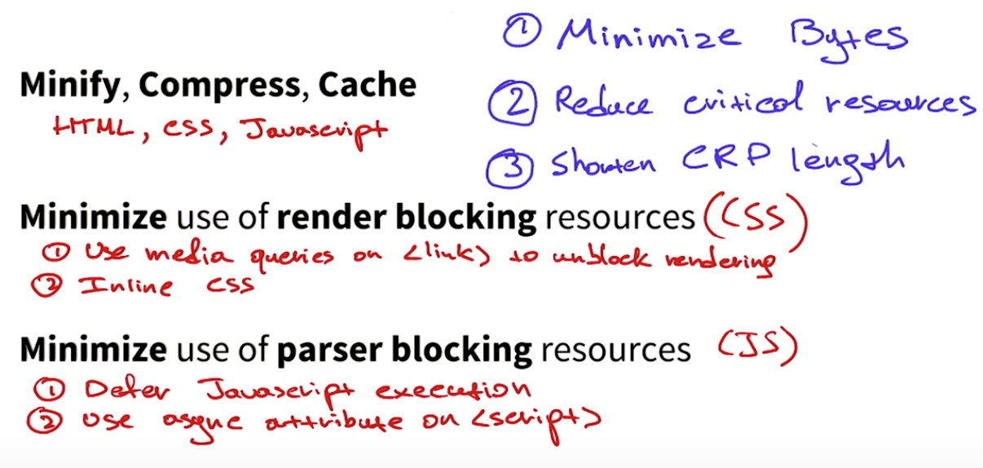

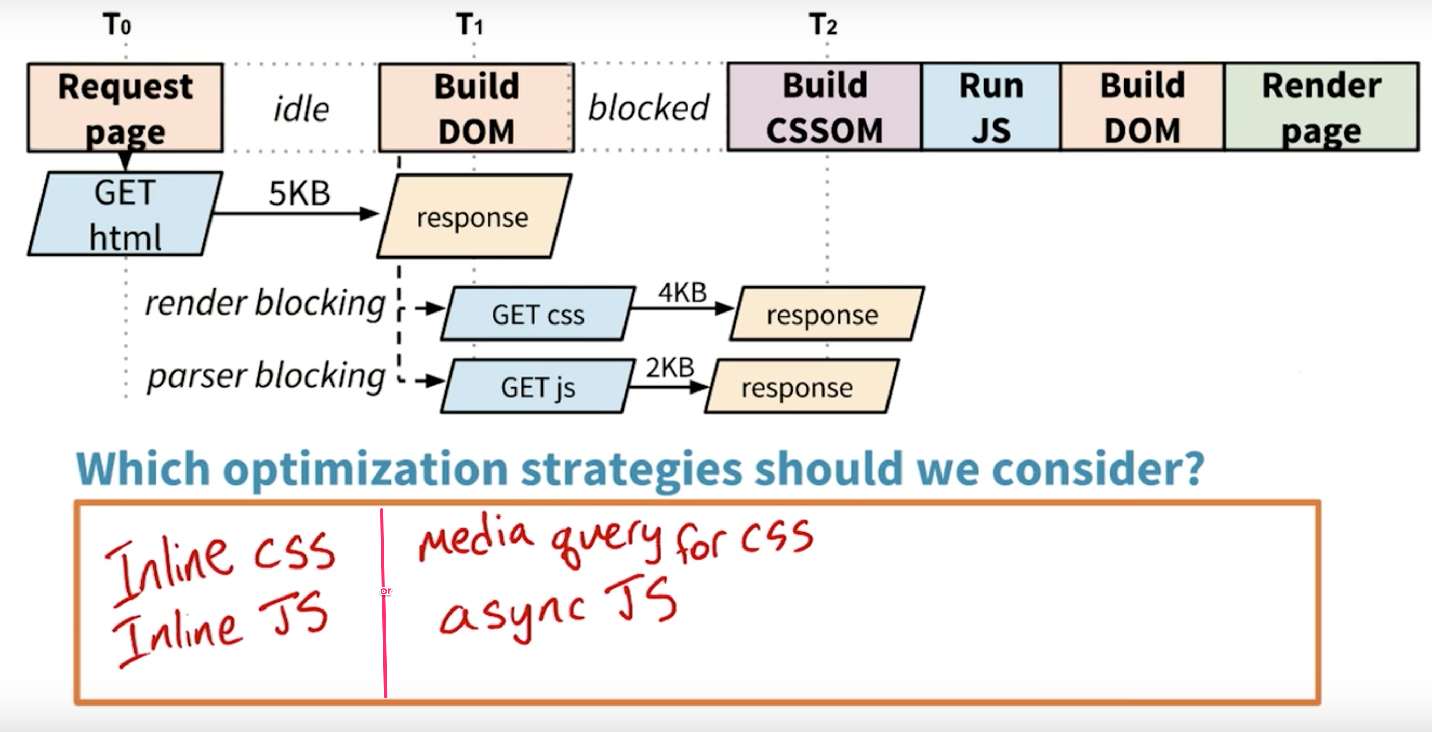

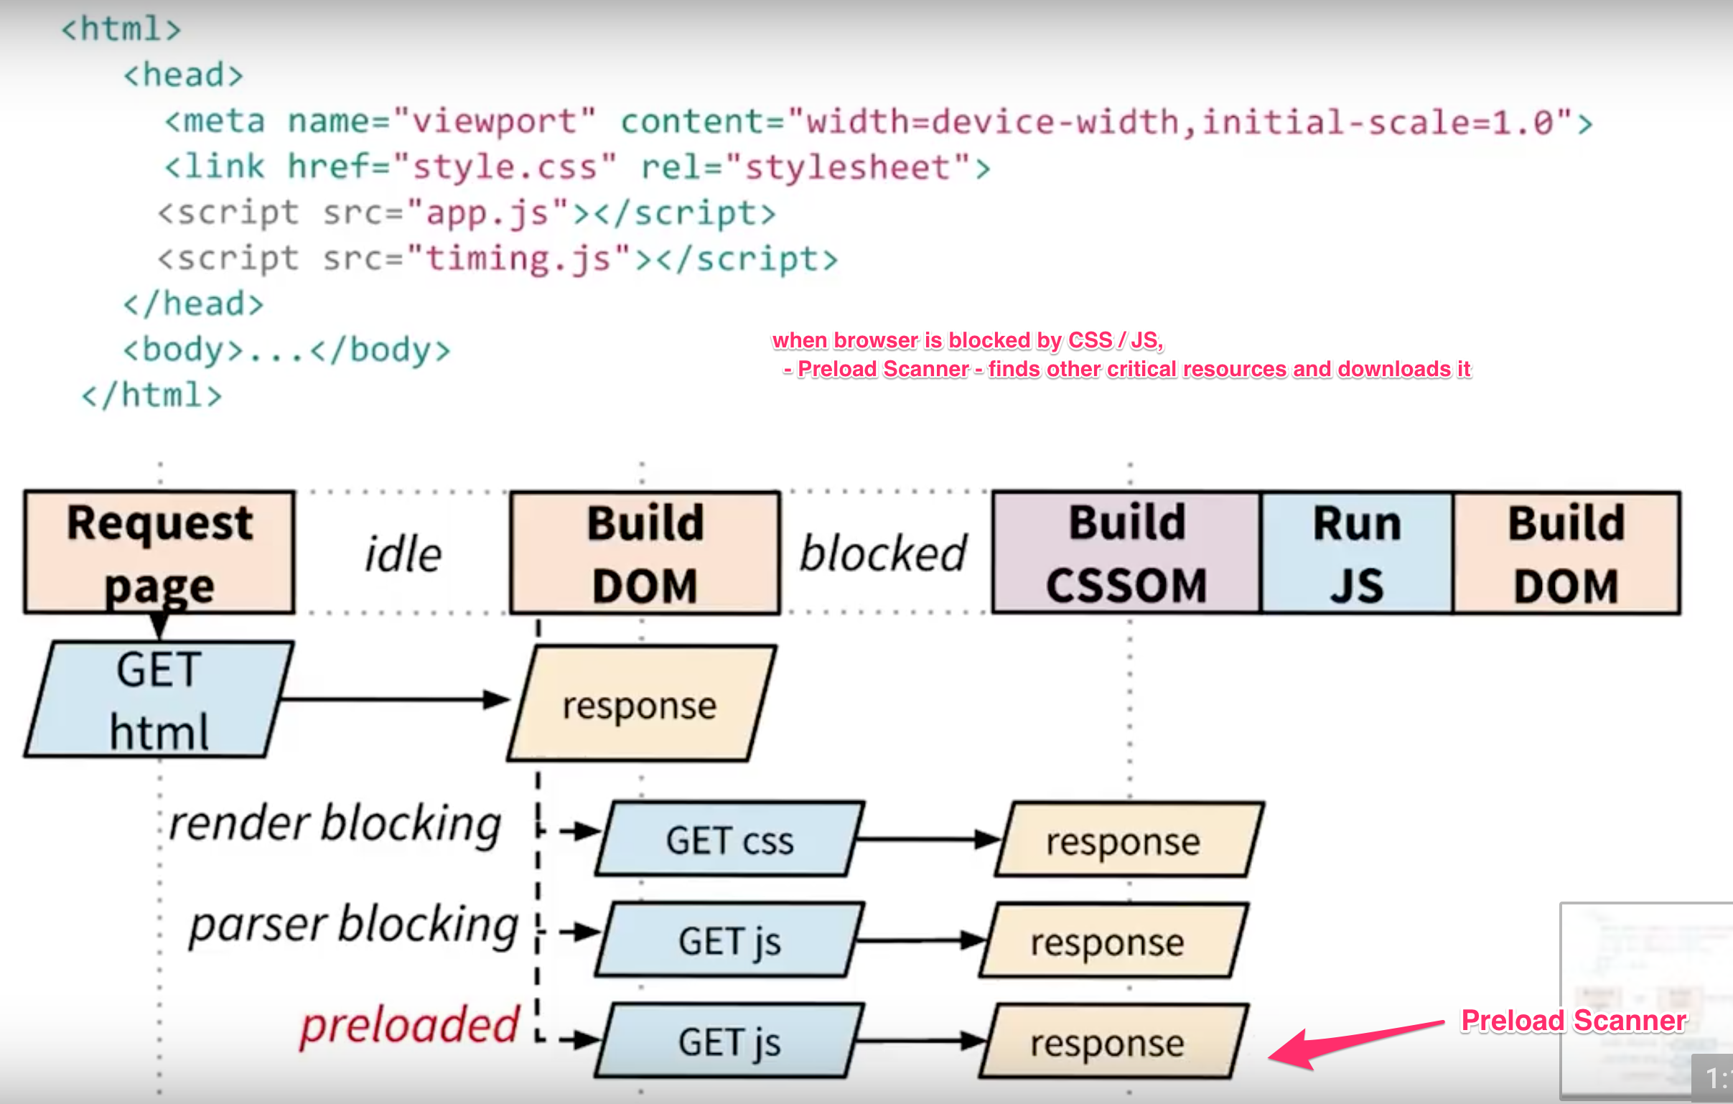

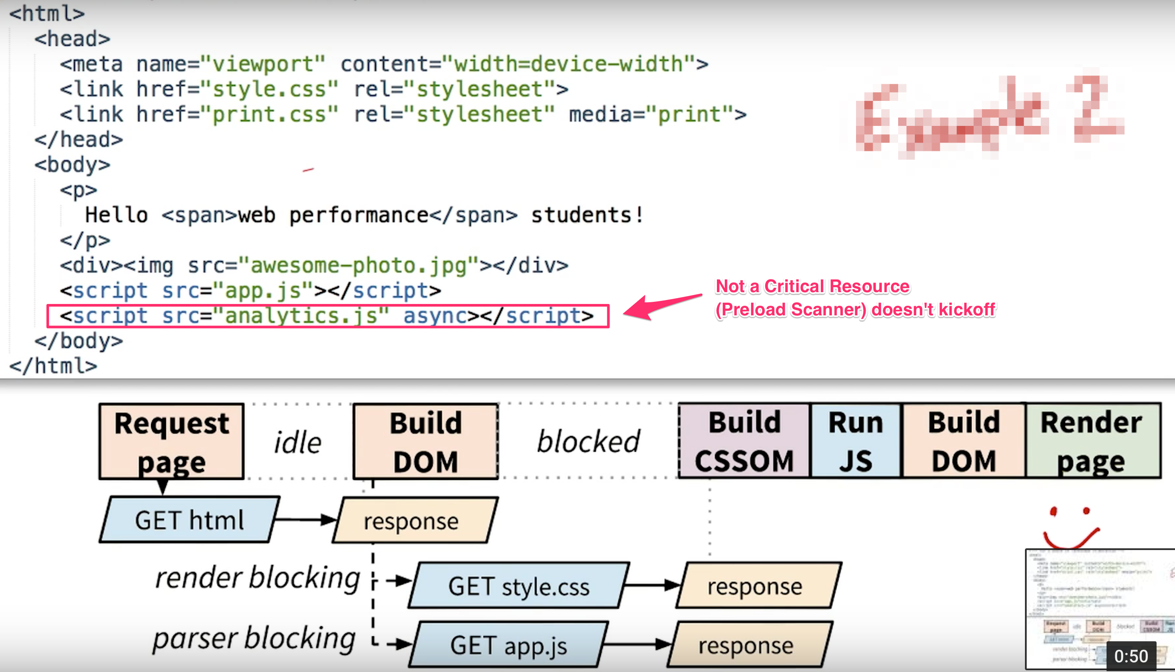

**Analyse: Reddit.com**

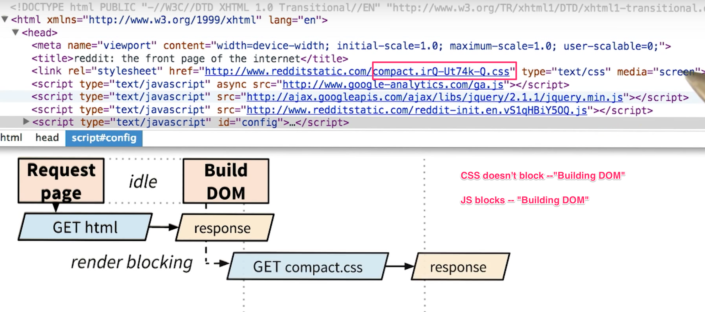

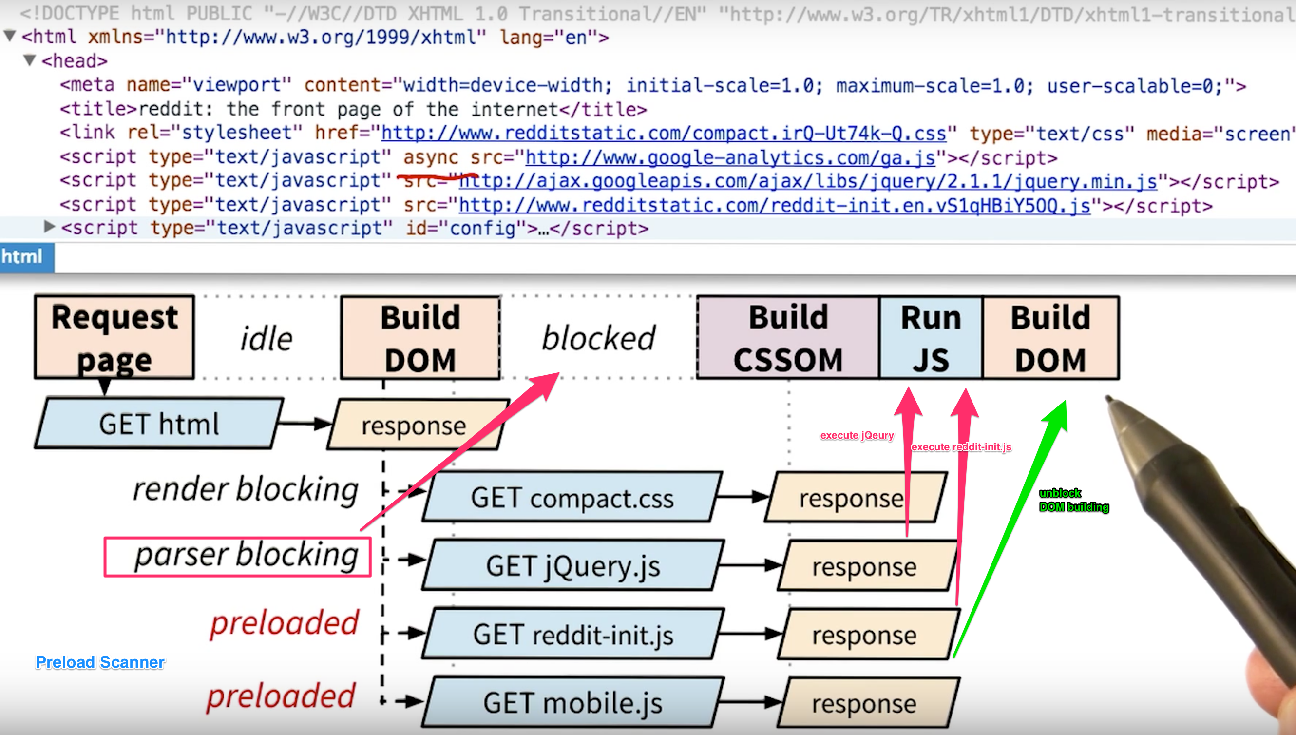

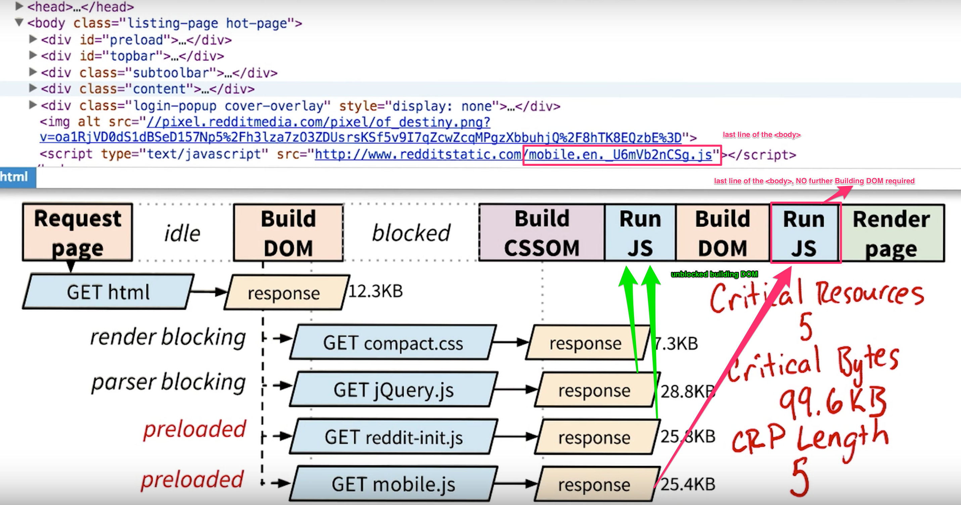

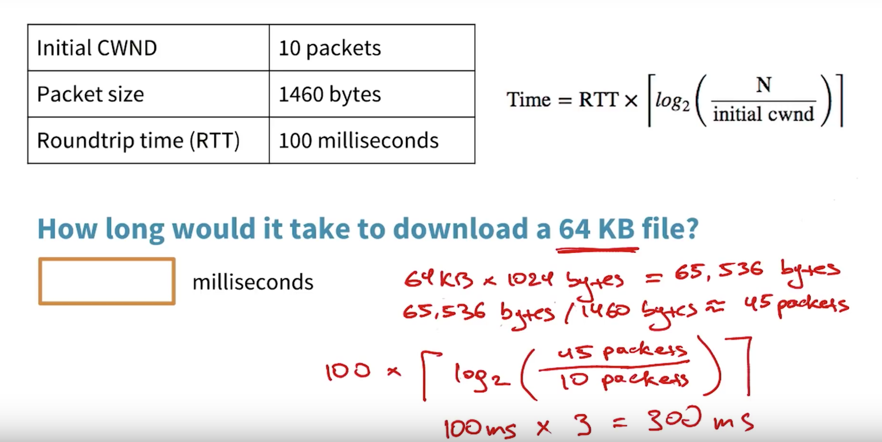

## Optimization Techniques

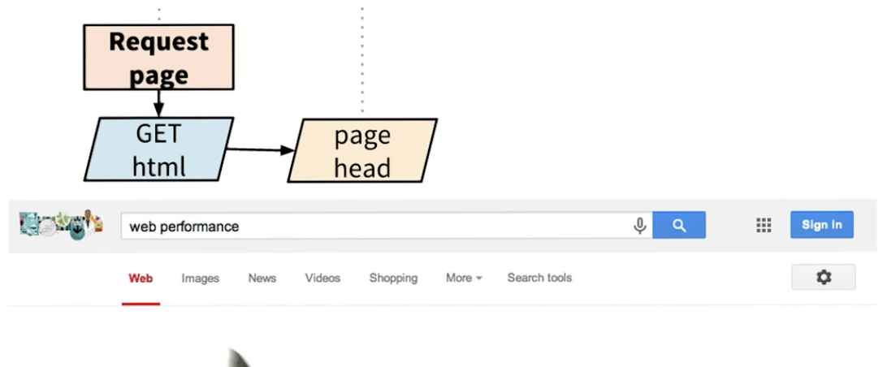

* Whenever you send a search request to Google, the server actually does something really, really clever.
* Before the server even knows what the search results are,
* it immediately returns the header of the page,
* This allows the browser to start processing the response
* and begin constructing the DOM incrementally, and potentially even render the header.
* Then, once the search results are ready, the rest of the HTML arrives,
* and the browser parses that and displays the content.

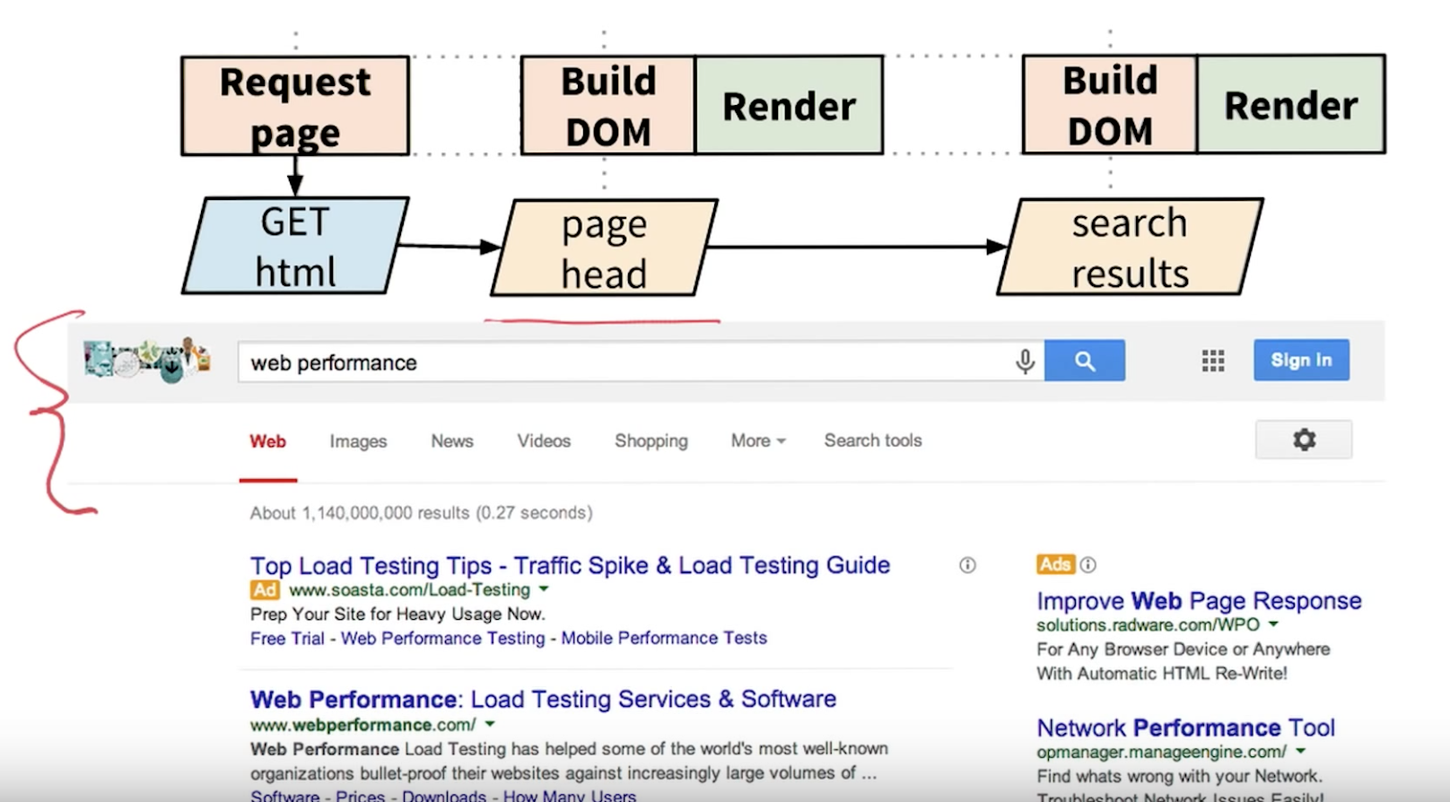

As you can see, the browser doesn't have to wait for all of the HTML to arrive before processing,

and neither should your server.

In fact, returning partial HTML can be a really nice performance optimization.

Incremental HTML delivery. Very clever idea

# viewport meta tags

<meta name="viewport" content="width=device-width, initial-scale=1.0, user-scalable=1.0, minimum-scale=1.0, maximum-scale=1.0">

width=device-width

This means, we are telling to the browser “my website adapts to your device width”.

initial-scale

This defines the scale of the website, This parameter sets the initial zoom level, which means **1 CSS pixel** is equal to **1 viewport pixel**. This parameter help when you're changing orientation, or preventing default zooming. Without this parameter, responsive site won't work.

maximum-scale

Maximum-scale defines the maximum zoom. When you access the website, top priority is maximum-scale=1, and it won’t allow the user to zoom.

minimum-scale

Minimum-scale defines the minimum zoom. This works the same as above, but it defines the minimum scale. This is useful, when maximum-scale is large, and you want to set minimum-scale.

user-scalable

User-scalable assigned to **1.0** means the website is allowing the user to zoom in or zoom out.

But if you assign it to user-scalable=no, it means the website is not allowing the user to zoom in or zoom out.

